Department of Government and International Studies
Ending academic year 2011-12 with a flourish…
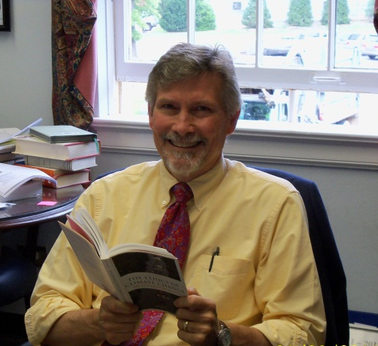
The academic year 2011-12 has been another busy and successful one for the Department of Government and International Studies. The faculty published books, journal articles, and book reviews, and presented papers at domestic and international conferences. Faculty also held positions of leadership on campus and on the executive boards of their professional associations. Students also distinguished themselves in the Model UN competition, as well as in national and local scholarship competitions.

The year began with Professor Kirsten Taylor as Chair of the Berry College Faculty Assembly, Professor Hickman as Director of Interdisciplinary Studies, and students Brin Enterkin and Jacob Stubbs leading the Student Government Association. Dr. Eric Sands was tenured and promoted to Associate Professor. The year,
Dr. Tom Kennedy
Dean, Evans School of Humanities, Arts & Social Sciences
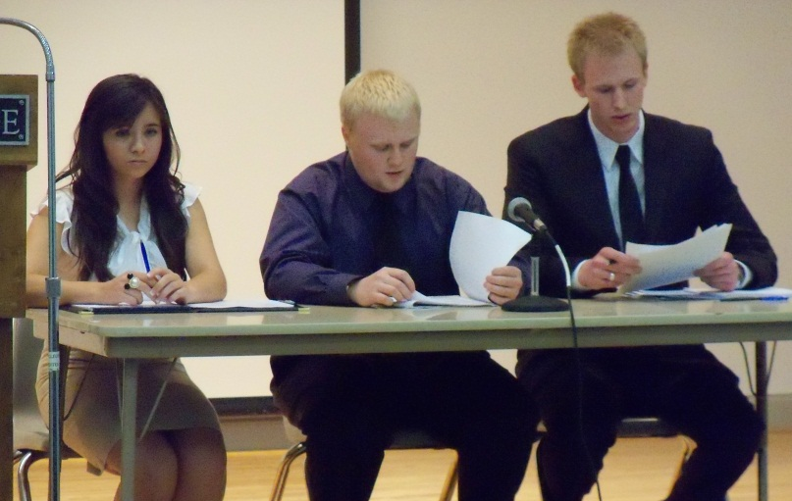
2011-2012, also marked the conclusion of the “Stuck with Virtue” series of conferences on the Berry campus, a series that was part of an extraordinary grant Professor Peter Lawler received from the University of Chicago and a series that brought an outstanding group of public intellectuals to the Berry campus. Students from the department were involved not only in hosting conference visitors to campus, but also presenting their own work as part of the proceedings. The symposia also resulted in publications in Perspectives on Political Science and The New Atlantis and books to be published by Northern Illinois and the University Press of Kentucky.

Professor Chaitram Singh published his second novel, The February 23rd Coup and embarked on research on another work of fiction, and Dr. Taylor’s textbook, (co-authored with Richard Mansbach), Introduction to Global Politics, came out in the second edition. Professor John Hickman published several articles on the politics of space and he, with the help of Professor Singh, continues the preparation for the Association of Third World Studies conference to be held at Berry in the fall of 2013.

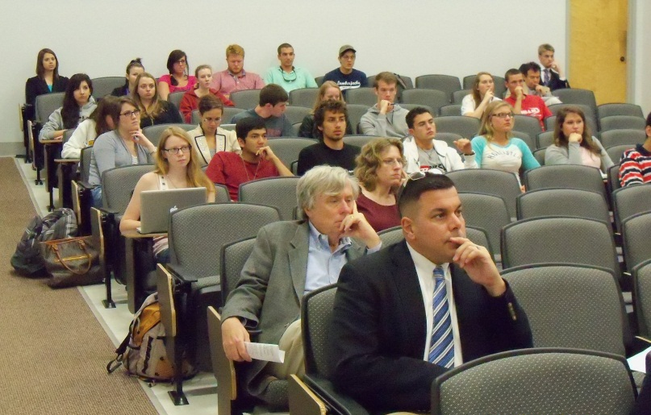
Professor Michael Bailey contributed ten pieces to the book, 30-Second Politics and, in the latter part of the spring semester, he, along with Berry students, engaged journalist/commentator, Cokie Roberts, in a vigorous discussion prior to her formal lecture as part of the Gloria Shatto series.
A large crowd turned out to hear political pundit Ross Douthat, who was introduced by a student from the department. Dr. Peter Lawler arranged for Douthat’s visit to Berry, which was funded by the Intercollegiate Studies Institute. Dr. Lawler, with ISI support, also sponsored a debate on the presidential selection process featuring the prominent journalists and master-bloggers, Jay Cost and Sean Trende.

Thank you, to all of the Government and International Studies faculty and students, for such sterling performance and for all you contribute to enrich the intellectual life at Berry. It was my pleasure to serve as Chair of this outstanding department this past year, and I look forward to a close working relationship in the academic year ahead.

Tom Kennedy, Ph. D.
Dean, Evans School of Humanities, Arts &Social Sciences
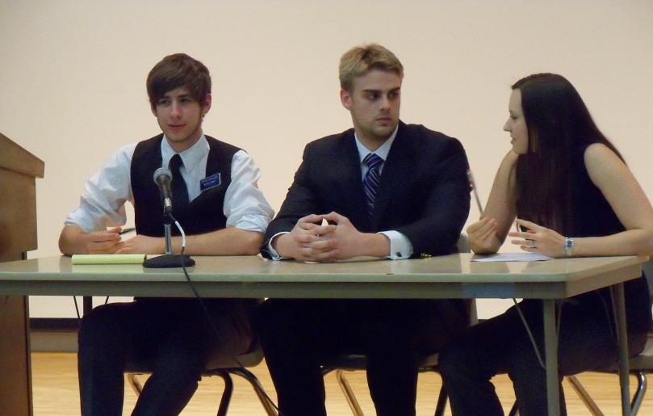
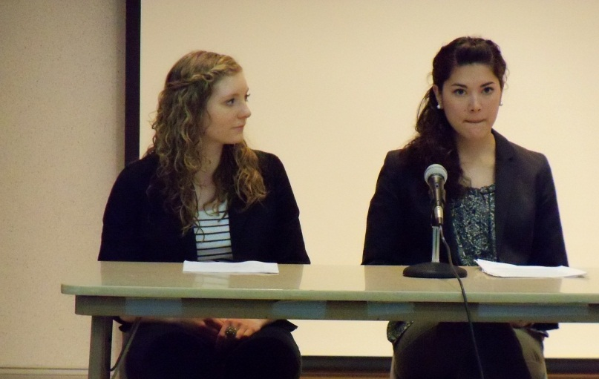
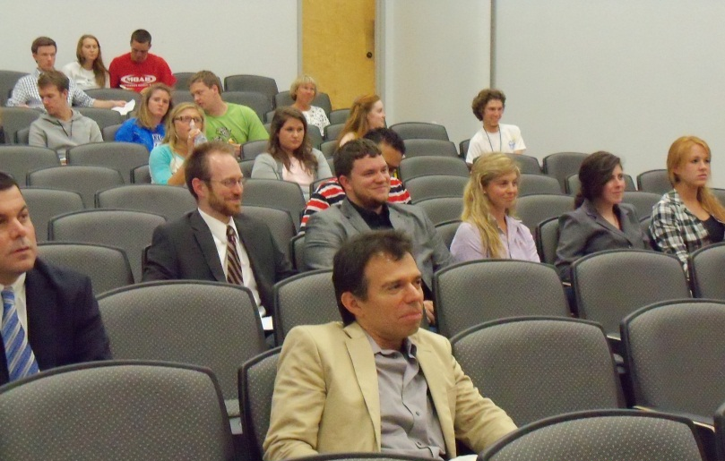
Faculty/Staff
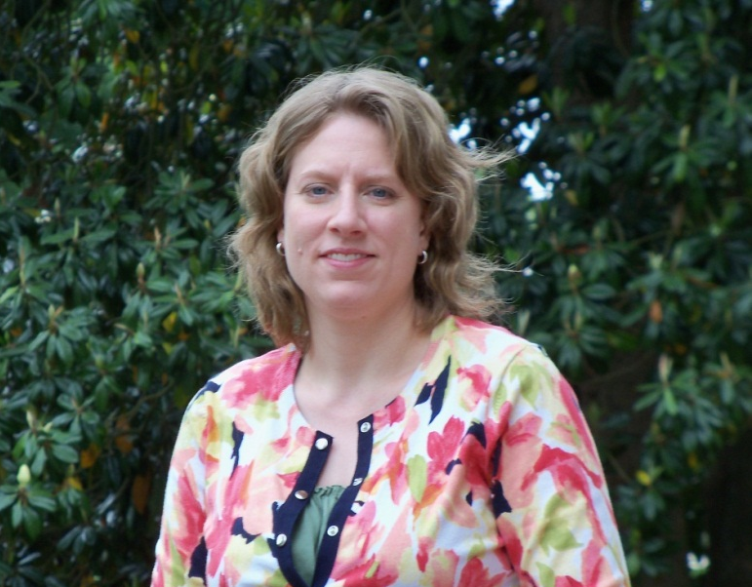

Dr. Kirsten Taylor
Associate Professor
Department Chair, July 1, 2012 -

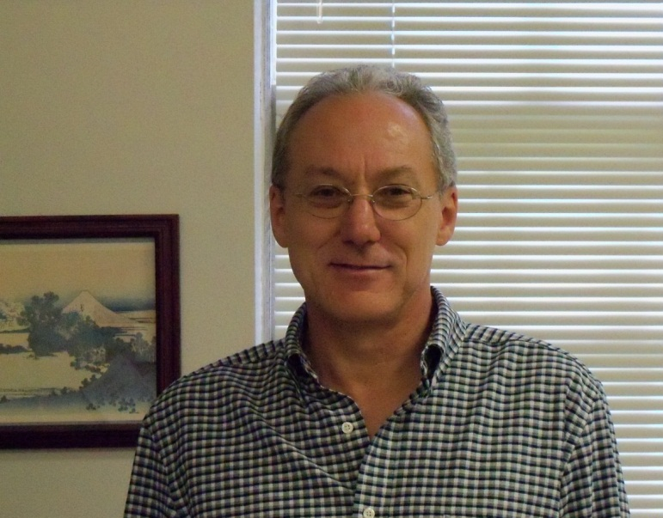
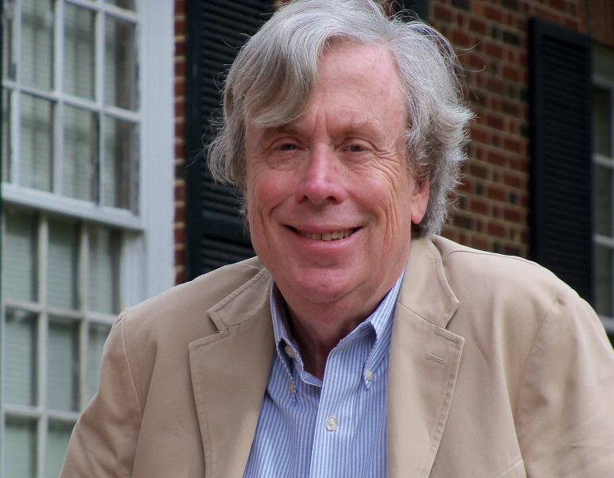

Dr. Peter Lawler
Dana Professor of Gov’t & Int’l Studies
Dr. John Hickman
Associate Professor
Director, Interdisciplinary Studies

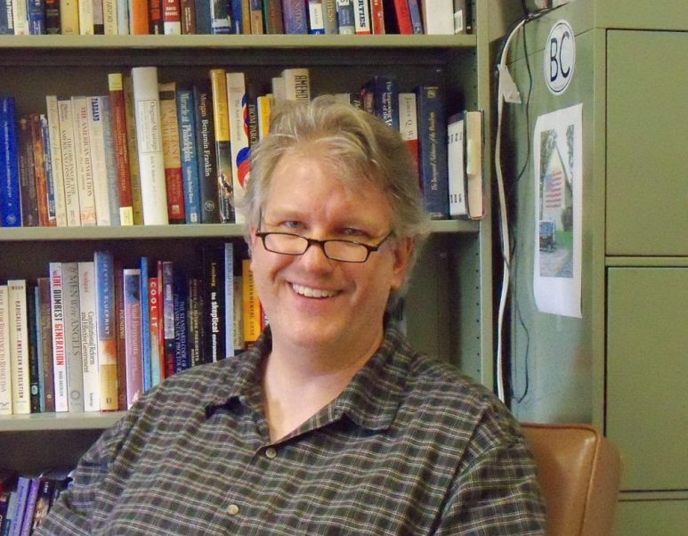
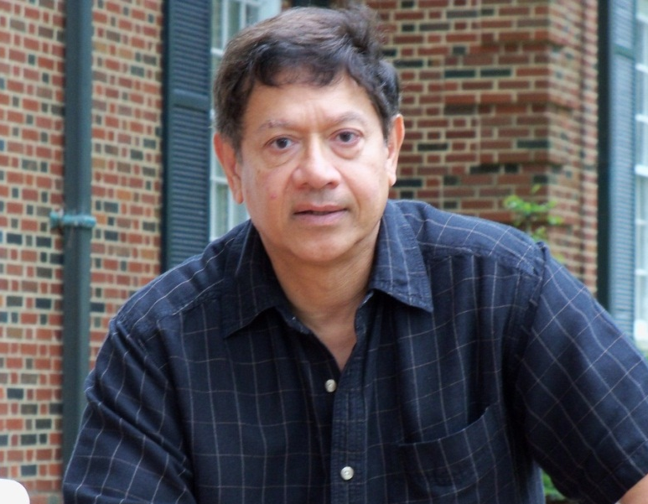

Dr. Chaitram Singh
Gund Professor of Gov’t & Int’l Studies
Dr. Michael Bailey
Associate Professor


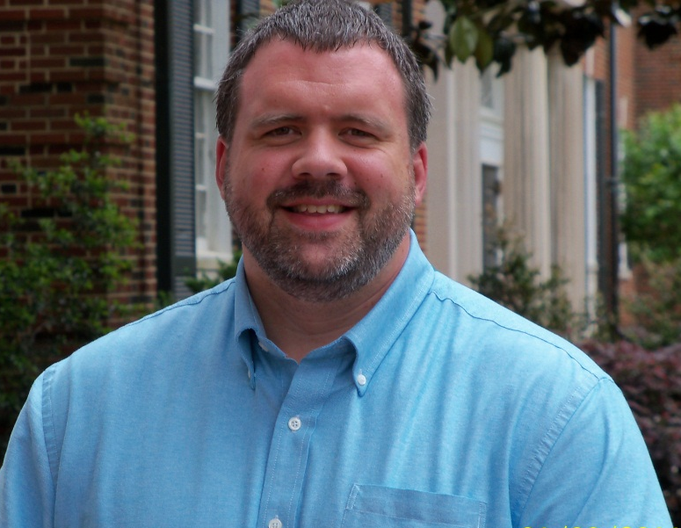

Dr. Eric Sands
Associate Professor
Ms. Darla Fox
Department Secretary

Student Scholarship on Display

“Higher Education Today”: Symposium Organized by
Dr. Peter Lawler and Funded by the Intercollegiate Studies Institute

April 19th, 2012

Student Panels

Session One – Moderator: Fan Xiong
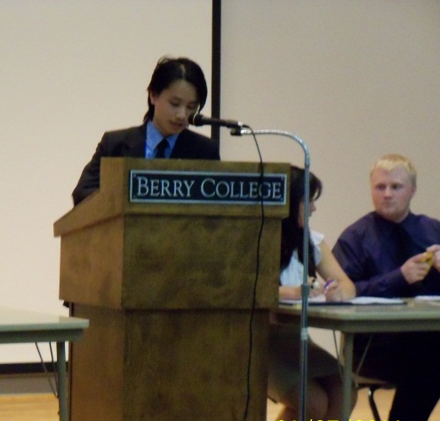
- What is Wrong with Immigration Policies? - Cory Wright (Berry College)
- Democracy and Aristocracy: Family, Women, and Technology - Brooke Hoppmeyer (Berry College)
- The Private Military Firm Industry - Zack Huffman (Berry College)
- Mapping Out Egypt’s Political Future - Amy Lynn Cherry (Berry College)
- Victims of Cambodia’s War Crime - Laura Smolley (Berry College)
- The Doctor is In: Using Language and Philosophy to Diagnose and Heal Societal Ills - Olivia Carroll (Lee University)
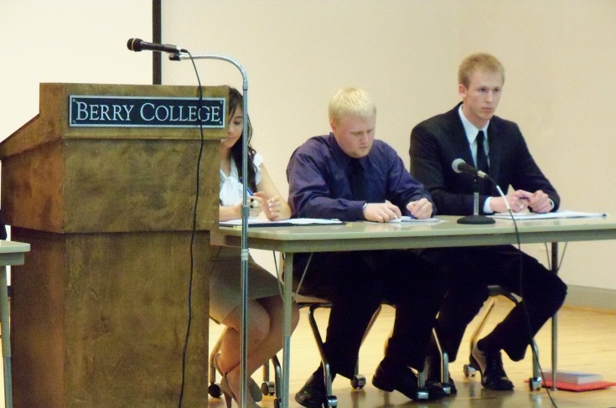

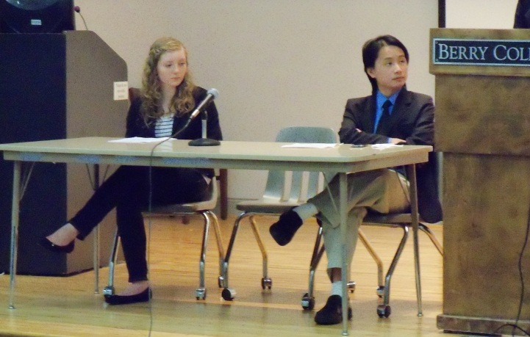
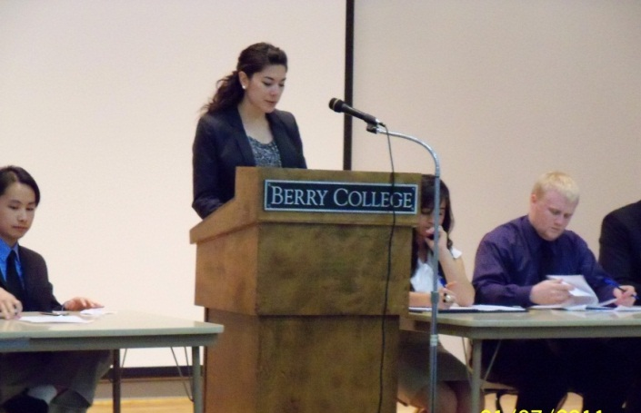

Session Two – Moderator: Kristian Canler
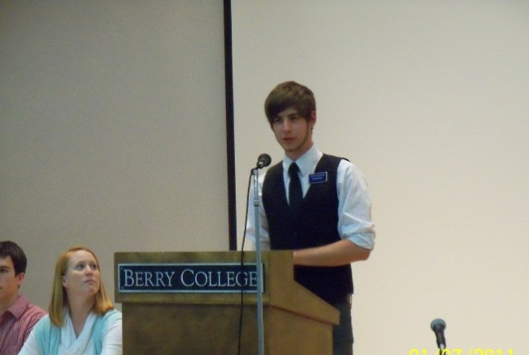
- Masculinity, Technology, and the 21st Century - Rex Bearden (Berry College)
- Politics, Metaphysically Understood Andrea K. Lowry (Berry College)
- The Beginning of Politics: A Look into the Nature of Man - Michael Schulte (Berry College)
Real Self-Government of Body by Soul: The Purpose of a Democratic Education - Elizabeth Dunagan (Berry College)
- Conservatism as Progress: Integrating Technology within a Liberal Framework - Zack German (Lee University)

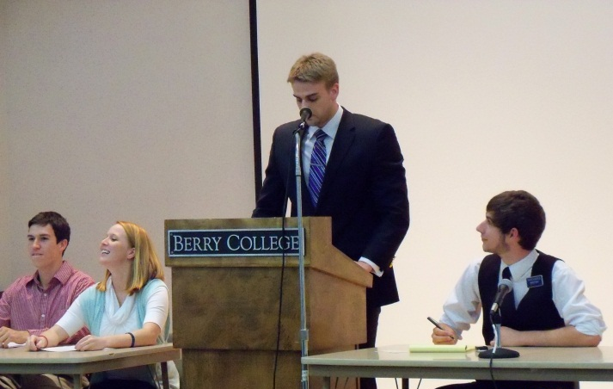
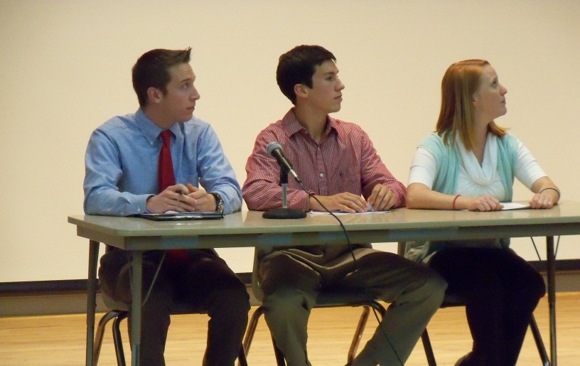
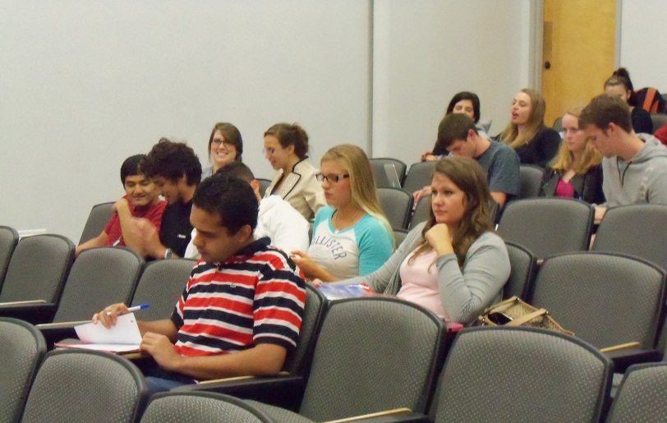
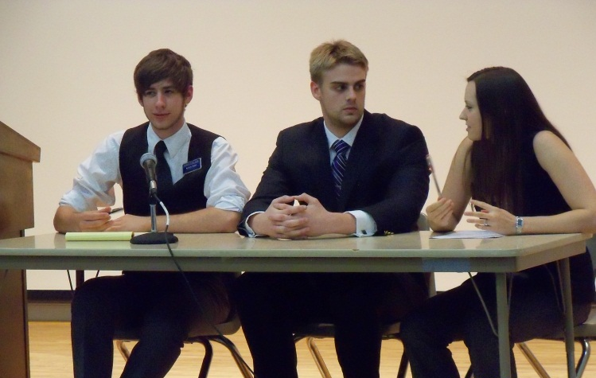

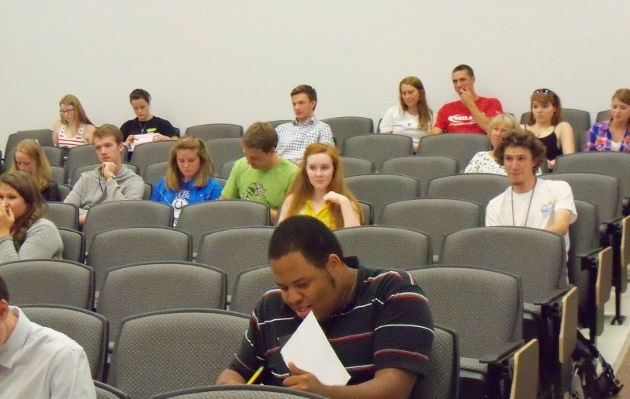
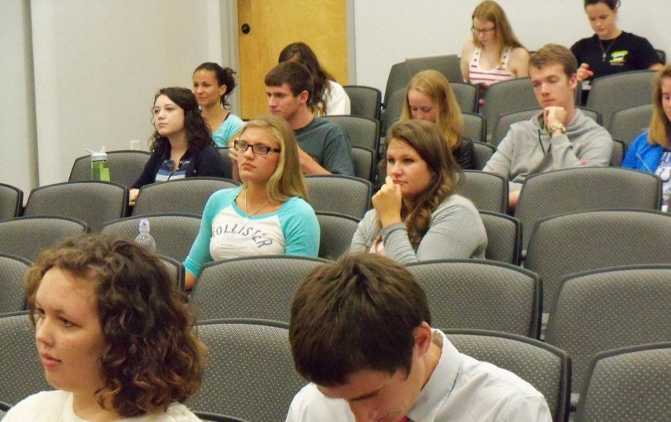

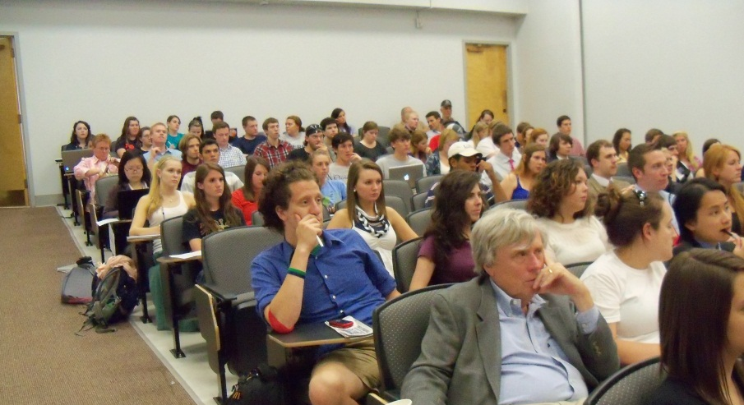

Guest Panel

Higher Education Today

Featured Speaker: Dr. Marc Guerra, Associate Professor and Director of Graduate Programs in Theology at Ave Maria University

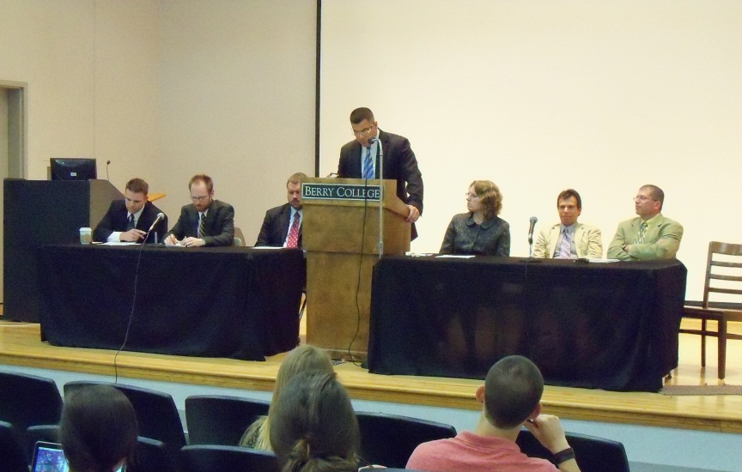

Respondents:

Dr. Brian Carroll (Berry College)
Dr. Kirsten Taylor (Berry College)
Dr. Michael Papazian (Berry College)
Dr. Chris Barnett (Berry College)
Dr. Tom Pope (Lee University)

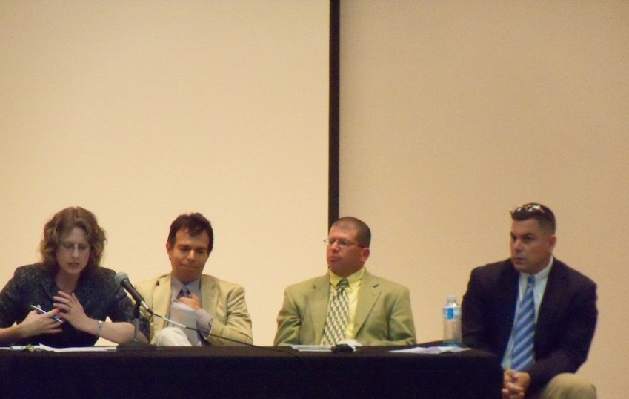
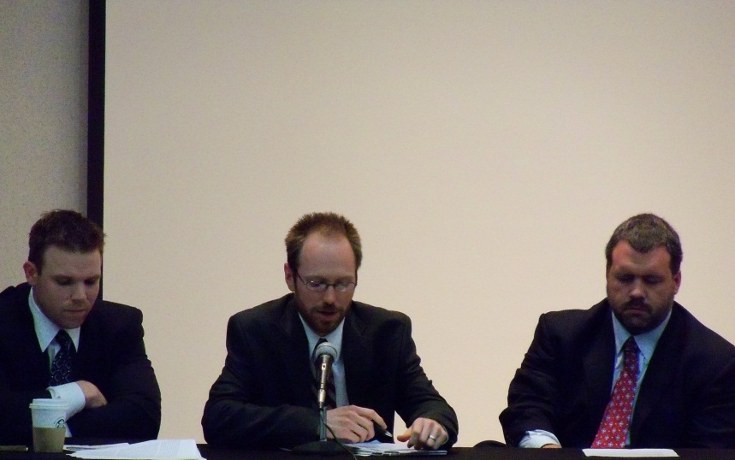

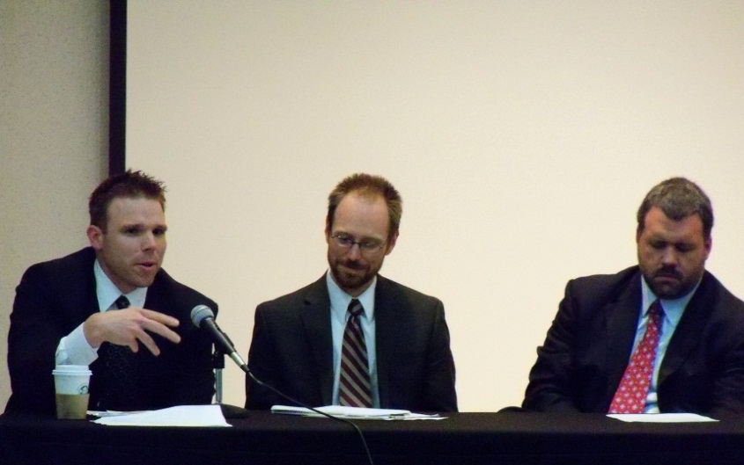
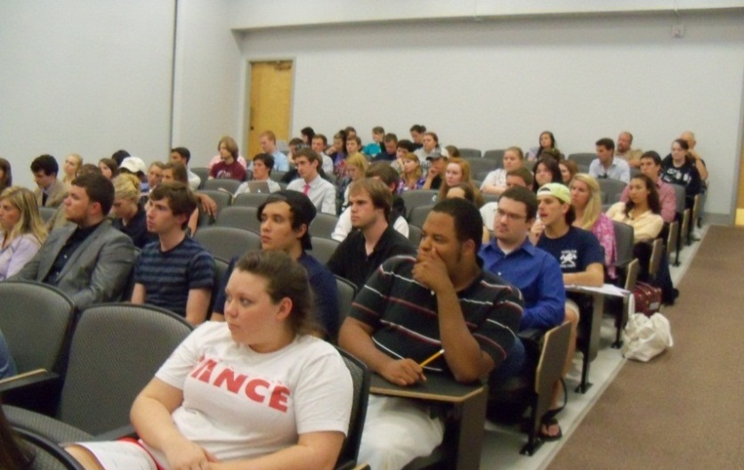

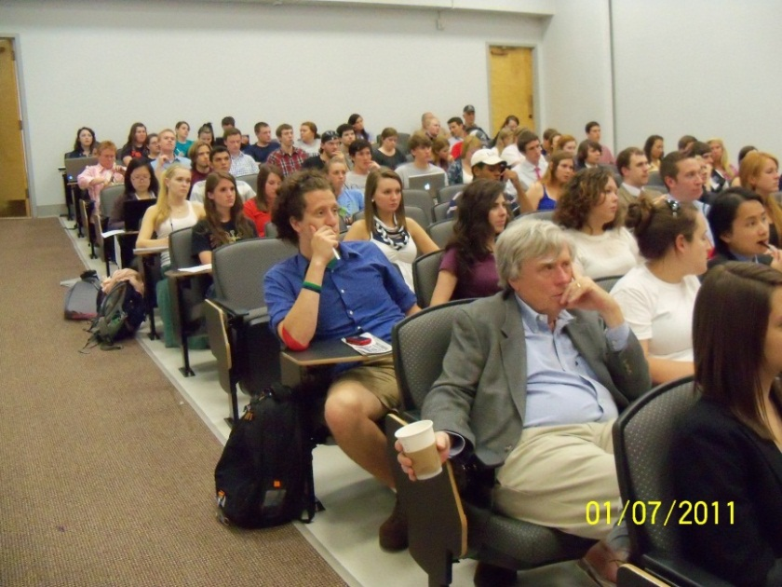
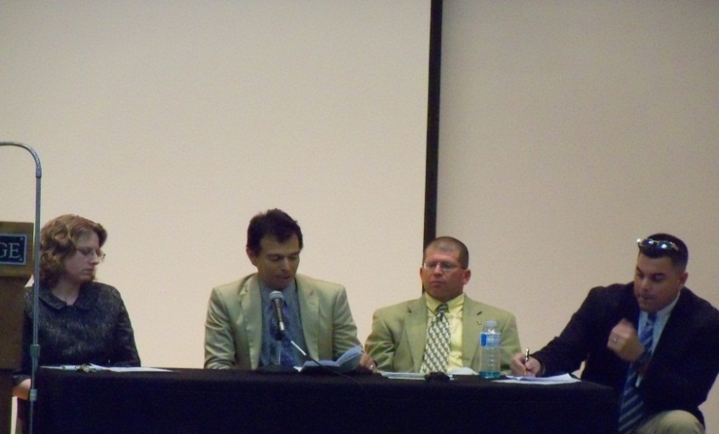

Reflections on Higher Education - Dinner Session

Mallory Owens (former Berry College SGA President)
Brin Enterkin (2011-2012 Berry College SGA President)
Jacob Stubbs (2012-2013 Berry College SGA President)

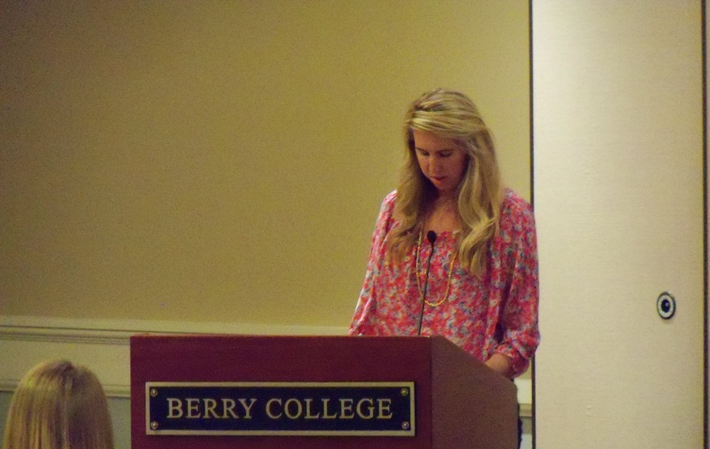
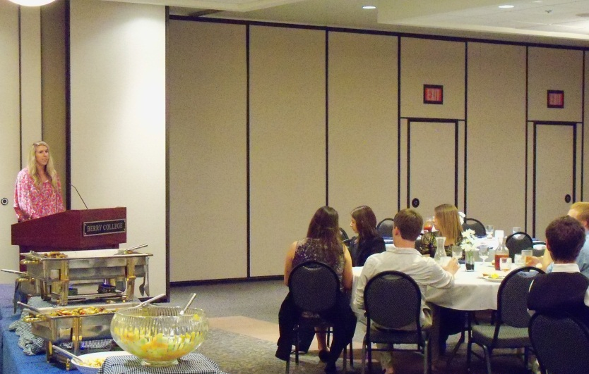

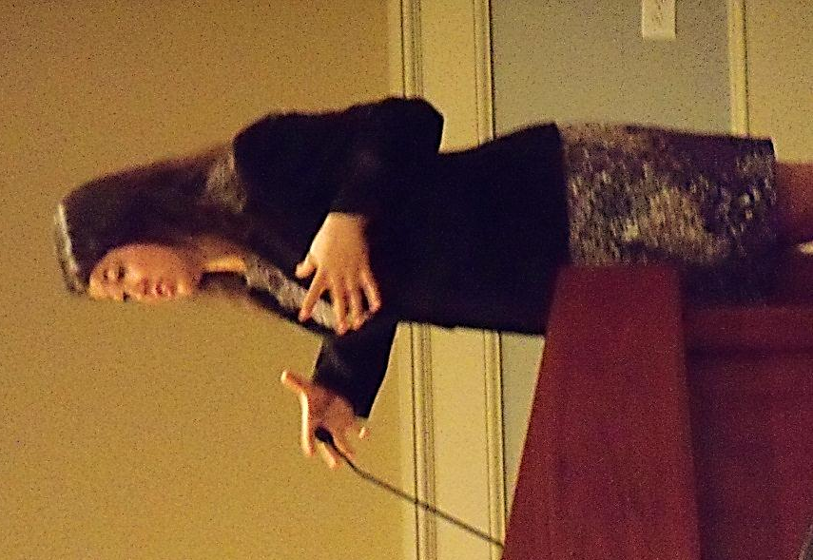
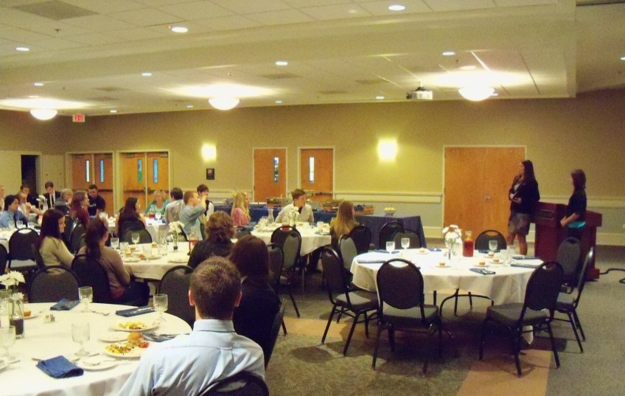
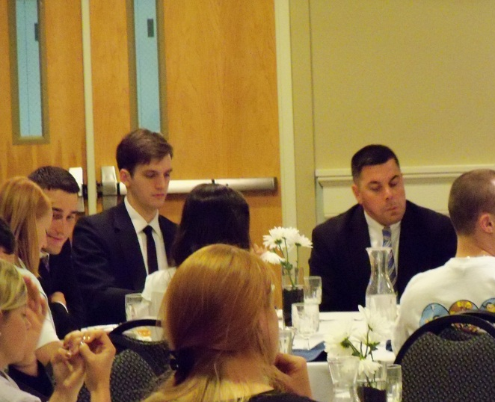

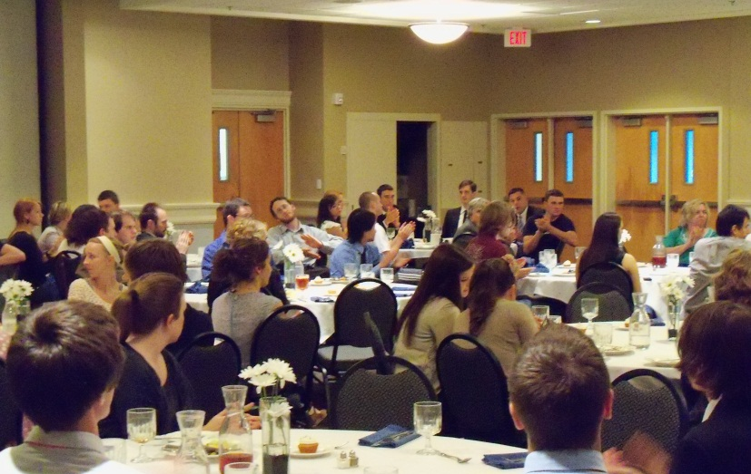
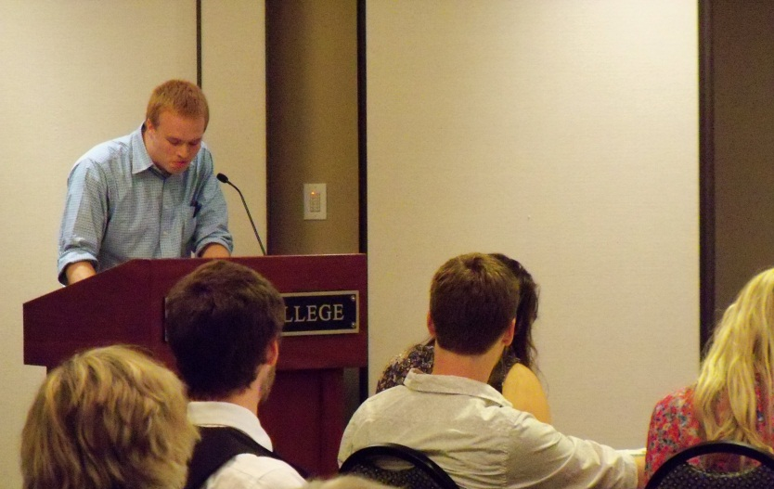

Faculty: Professional Activities

Dr. Michael Bailey

Chair, Department of Government and International Studies, 2008-2011

Contributions to books:
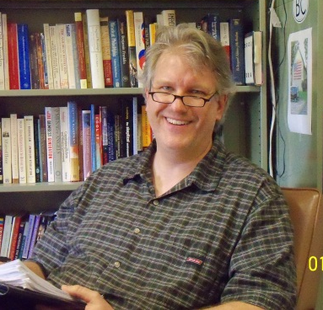
Bailey, Michael E. “Aristocracy.” “Anarchism.” “Classical liberalism.” “Conservatism.” “Liberalism.” “Libertarianism.” “Executive Power.” “Separation of Powers.” “Checks and Balances.” “Capitalism.” 30-Second Politics: The 50 most thought-provoking theories in politics, each explained in half a minute. Ed. Steven Taylor. NY: Ivy Press Limited, 2011.

“Monotheistic Religions and the Public Square.” In Fostering Religious Literacy Across Campus, ed. Miriam Rosalyn Diamond. Co-authors, Thomas D. Kennedy, Brian Carroll and Michael E. Bailey (Stillwater, OK: New Forums Press Inc, 2011)

Column:
John Hickman. “Southern Views: Michael Bailey on American Exceptionalism.” Like the Dew. October 7, 2011.
http://likethedew.com/2011/10/07/michael-bailey-on-american-exceptionalism/

Conference Papers:

“The Political Implications of the New Atheism,” Delivered at the MPSA Annual Meeting in Chicago, IL, March 31, 2011.

Lectures:

“American Exceptionalism: Past, Present and Past Again,” Constitution Day Speaker, University of West Florida and the Escambia County School District, September 16, 2011

“The Electoral College: Perfect Fit or Perfect Folly,” delivered to the Escambia County School District, September 16, 2011

Other Professional Activities:

Interview. Michael Bailey as interviewed by John Hickman for Like the Dew. “Southern Views: Michael Bailey on American Exceptionalism” http://likethedew.com/2011/10/07/michael-bailey-on-american-exceptionalism/

Discussant, “Religion, Leadership, and Political Preferences,” MPSA Annual Meeting, April, 2011, Chicago, IL
Discussant for Panel, “Signing Statements: Posturing or Policymaking?,” MPSA Annual Meeting, March 31, 2011, Chicago, IL
Introduced Cokie Roberts and moderated the 4:00 pm session of Gloria Shatto Lecture, March 29, 2012
Respondent to Paul Wallace’s talk, “Idols and Icons: On atheism, science and religious belief.”

Dr. John Hickman

Chair, Interdisciplinary Studies, Berry College

Book:

John Hickman. Explaining Guantanamo. University Press of Florida (Forthcoming).

Articles:

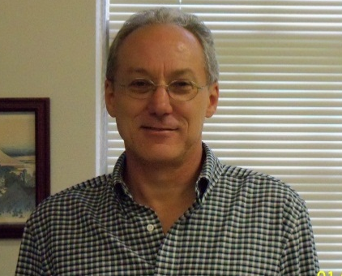
John Hickman, “How Plausible is Chinese Annexation of Territory on the Moon?” Astropolitics. (2012) 10:84-92.
John Hickman, “Why and How States Open Frontiers.” The Journal of Slavic and Military Studies. (2012) 25,1:1-16.
John Hickman. “Ukraine in NATO? The Case Against.” Nowa Ukraina. (2011): 11:125-128.
Chaitram Singh and John Hickman, “Soldiers as Saviors of the State: The Cases of Turkey and Pakistan Contrasted,” Journal of Third World Studies (Forthcoming)
Columns:
John Hickman. “Who Wants Intervention?” Like the Dew. April 12, 2012.
http://likethedew.com/2012/04/12/who-wants-intervention/
John Hickman. “The Cause of Freedom.” Like the Dew. April 8, 2012.
http://likethedew.com/2012/04/08/the-cause-of-freedom/
John Hickman. “The Permanent War Party Wants Two More.” Like the Dew. March 11, 2012.
http://likethedew.com/2012/03/11/the-permanent-war-party-wants-two-more/
John Hickman. “Bad Double Standards, Good Double Standards.” Like the Dew. January 17, 2012.
http://likethedew.com/2012/01/17/bad-double-standards-good-double-standards/
John Hickman. “Reporting Kepler 20e and 20f.” The Space Review. January 9, 2012.
http://www.thespacereview.com/article/2001/1
John Hickman. “Widening the War on Drugs.” Like the Dew. October 9, 2011.
http://likethedew.com/2011/10/09/widening-the-war-on-drugs/

John Hickman. “Southern Views: Michael Bailey on American Exceptionalism.” Like the Dew. October 7, 2011.
http://likethedew.com/2011/10/07/michael-bailey-on-american-exceptionalism/

John Hickman. “Southern Life: Time for Some Good News: Tick Season is Ending.” Like the Dew. August 11, 2011.
http://likethedew.com/2011/08/11/time-for-some-good-news-tick-season-is-ending-and-tick-borne-disease-is-scarier-elsewhere/
John Hickman. “High Expectations: Utopianism and Cornucopianism in the Early Modern Era and the Space Age,” The Space Review. August 1, 2011.
http://www.thespacereview.com/article/1897/1

Conference Paper:
“Electoral Competition in Uganda,” paper presented at the Association of Third World Studies 2011 Annual Conference, Salvador, Brazil, November 22, 2011.

Lecture:

“Africa: Problems and Issues," at Seminar "Major Problems and Issues in Contemporary South Asia and Africa," Georgia Southwestern University, Americus, GA, October 10, 2011.

Dr. Peter Lawler

Books

A Political Companion to Walker Percy, edited with Brian Smith (University Press of Kentucky, forthcoming)

Descartes, Locke, Darwin, and the Science of Modern Virtue, edited with Marc Guerra (Northern Illinois University Press, forthcoming)

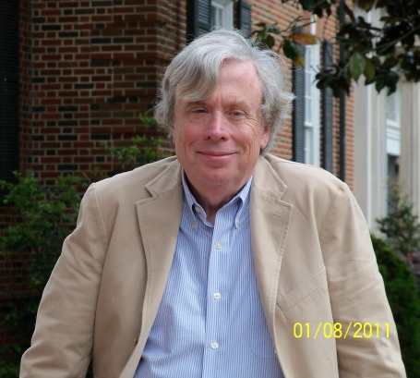
Allergic to Crazy: Quick Reflections on Politics, Education, and Culture (St. Augustine's Press, forthcoming)

Book Chapters:

“American Nominalism and Our Need for a Science of Theology,” Gained Horizons: Regensburg and the Enlargement of Reason, ed. B. Cowan (St. Augustine’s Press, 2011).

"Being a Person These Days," A Second Look at First Things: A Case for Conservative Politics (The Hadley Arkes Festschrift) , ed. F. Beckwith and S. McWilliams (St. Augustine's Press, 2012)

"Chantal Delsol on Human Rights and Human Dignity," Lucid Mind, Intrepid Spirit: Essays on the Thought of Chantal Delsol, ed. L. Hall and P. Seaton (Lexington Books, 2012).

"Defending the Personal Logos Today," The Claims of Faith and the Practice of Political Philosophy, ed. P. Dehart and C. Holloway (forthcoming from Northern Illinois University Press).

“Dignity and Higher Education Today,” The Idea of the American University, ed. B. Watson (Lexington Books, 2011)

"Locke, The Puritans, and America," Natural Right and Poliitical Philosophy, ed. L. Ward and A. Ward (University of Notre Dame Press, forthcoming, 2012).

"Locke, Darwin, and the American Future," Darwin and Liberalism, ed. S. Dilley (Springer, forthcoming, 2012).

"Solzhenitsyn and the Challenge of Our Technological Civilization," Jerusalem, Athens, and Rome: Essays in Honor of James Schall, ed. M. Guerra (St. Augustine's Press, 2012).

"Locke, Darwin, and the Science of Modern Virtue," Descartes, Locke, Darwin, and the Science of Modern Virtue (referenced above)

“Tocqueville on How to Praise the Puritans Today,” Tocqueville and Statesmanship, ed. B. Domoff and J. Herbert (Lexington Books, 2011)

“Tom Wolfe, Walker Percy, and Being Stuck with Virtue,”Perspectives on Political Science, July, 201l—with Marc Guerra. This is part of a symposium edited by Guerra and Myself.

"Walker Percy, Alexis de Tocqueville, and the Stoic and Christian Foundations of American Thomism," A Political Companion to Walker Percy (referenced above).

Articles:

"American Prospects," Commentary, Fall, 2011.

"Change We Can Actually See (And Half-Believe in)," The Intercollegiate Review, Fall, 2011.

"The Cloned Soul," The City, Winter, 2011.

“Judging Neoconservatism,” The Family in America, Summer, 2012.

“Learning from Tocqueville on the French,” The City, Summer, 2011.

“Liberalism within Limits,” The American Conservative, April, 2011.

"The Truth About Higher Education," Academic Questions, Fall, 2011.

"Tocqueville's Aristocratic Christianity," The Catholic Social Science Journal, 2012 (an annual journal)

"Locke and the Science of Virtue," Society (forthcoming)

“Tocqueville’s Contribution to the American Reconciliation of Greatness and Justice in a True Understanding of Human Liberty,” Le Seguardo—Revista di Filosophia, no. 3 (2011)—This was a contribution to a kind of virtual conference at the University of Rome.

"Why We Need a Stuck with Virtue Science," The New Atlantis (issue referenced below)—written with Marc Guerra

Edited Journal Symposia (with Marc Guerra):

"Toward a Stuck with Virtue Science," The New Atlantis (Summer, 2011--published November, 2011)

“Walker Percy and Tom Wolfe,” Perspectives on Political Science (Summer, 2011)

Invited Lectures:

“Tocqueville Was Wrong on Individualism? Mercer University, April, 2011.

“The Virtue Required for Indefinite Longevity,” Drummond Lecture, St. Louis University, April, 2011.

“The Road to Serfdom Never Gets to Serfdom,” Princeton University, May, 2011.

“Change We Can Half Believe in,” Intercollegiate Studies Institute, July, 2011.

"The Road to Serfdom Never Gets to Serfdom," The American Political Science Association, September, 2011.

"Tocqueville's Aristocratic Christianity," The American Political Science Association, September, 2011.

"What's New About Manent?" Baylor University, September, 2011.

"Just War Theory," The Tikvah Program on the Jewish Renaissance, September, 2011.

"The Covertly Coercive Transhumanists," debate with Ronald Bailey, Wheaton University (MA), October, 2011.

"Locke and the Family Today," Brigham Young University, November, 2011.

"Transhumanism and Indefinite Longevity," Union University, November, 2011

"Health Care and Bioethics," The Heritage Foundation, January, 2012.

"Tocqueville and Liberal Education," Assumption College, February, 2012.

"Making Virtue User Friendly," Fort Meyer, FL, February 2012.

"Two Years of Being Stuck with Virtue," University of Chicago Science of Virtues Project, March, 2012.

"Individualism, Indefinite Longevity, and Our Birth Dearth," Louisiana State University, March 2012.

"The Modern Science of Virtue," Midwest Political Science Association, April, 2012.

"Brian Benestad and the Modern Person," Midwest Political Science Association, April 2012.

Other Professional Activities:

Completed with Marc Guerra a two-year cycle of major conferences funded by the University of Chicago Science of Virtues Project. There was a conference at Berry in November 2011 on public policy and a wrap-conference in Fort Meyer, FL in February, 2012.

Executive editor of the refereed journal Perspectives on Political Science.

Over two hundred blog entries on Big Think, named by Time magazine the outstanding blog for news and information.

Georgia Author of the Year (essay) for Modern and American Dignity.

Dr. Eric Sands

Pre-Law Advisor and Coordinator for Legal Studies
Book Chapters:
“Abraham Lincoln and the Natural Law Republic,” The Triumphs and Travails of the Natural Rights Republic (Mercer University Press) – Forthcoming
Lectures:
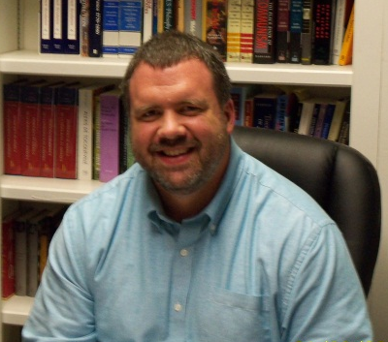
“The Art of Liberty: The Faces in America,” Midwest Political Science Association, April, 2012.
“Lincoln and the Natural Law Republic,” Christopher Newport University, Newport News, VA, February 23, 2012.
“Tocqueville and America,” Oak Hill Senior Scholars Program, Mount Berry, GA, Fall 2011.
“The Problem of Big Government,” Berry College, Mount Berry, GA, September 20, 2011.
“Constitutional Development: Problems and Solutions,” Rome, GA, September 1, 2011.
“Lincoln’s Serious Use of Humor,” Washington, D.C., July 2011.
Instructor for the Congressional Academy for American History & Civics, Washington, D.C., July 2011.
“150 Years of Controversy: Lincoln and the Civil War,” Oak Hill Senior Scholars Program, Mount Berry, GA, Spring 2011.
Award: Inducted into Phi Kappa Phi
Dr. Chaitram Singh
Books:

Chaitram Singh, The February 23rd Coup: A Novel (Bloomington, IN:I-Universe, 2011) & The Flour Convoy (Bloomington, IN: I-Universe, 201) Re-published.

Articles:

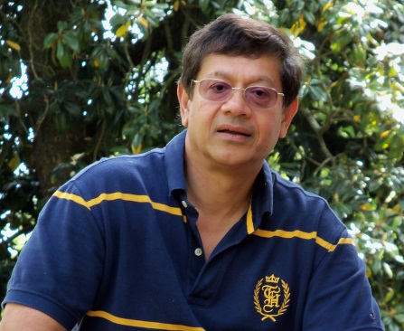
Chaitram Singh, “Military Coups and the Corporate Interests Hypothesis,” Journal of Third World Studies (Spring 2012).

Chaitram Singh and John Hickman, “Soldiers as Saviors of the State: The Cases of Turkey and Pakistan Contrasted,” Journal of Third World Studies (Forthcoming).

Conference Paper:

“Soldiers as Saviors of the State: The Cases of Turkey and Pakistan Contrasted,” paper presented at the Third World Studies Conference, Salvador da Bahia, Brazil, November 22, 2011.

Lecture:
"South Asian Security Issues,” at Seminar "Major Problems and Issues in Contemporary South Asia and Africa," Georgia Southwestern University, Americus, GA, October 10, 2011.

Other Professional activities:
Associate editor (Latin America), Journal of Third World Studies

Chair, Information Services Committee, Association of Third World Studies

Editor, ATWS Newsletter

Award:

Association of Third World Studies Presidential Award “in recognition of his outstanding contributions to the promotion of scholarship devoted to the Third World.”

Dr. Kirsten Taylor

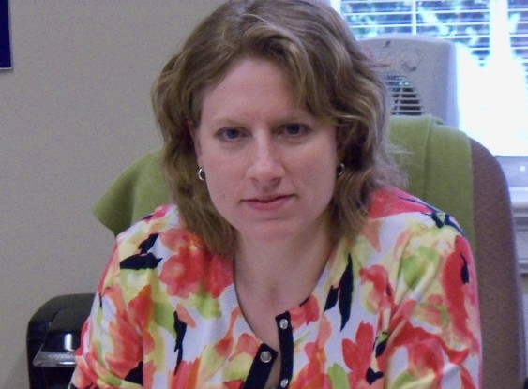
Chair, Faculty Assembly, Berry College

Faculty Advisor, Berry College Model United Nations

Book:

Mansbach, R. W., & Taylor, K. L. (2012) Introduction to Global Politics, 2nd Edition. London, England: Routledge.
Article:
Taylor, K. L. "Simulations Inside and Outside the IR Classroom: A Comparative Analysis," International Studies Perspectives (Forthcoming)
Some News of Graduating Students

Brin Enterkin of our department received the William E. Simon Fellowship for Noble Purpose. This fellowship recognizes a graduating college senior who is pursuing a life dedicated to and distinguished by honor, generosity, service, and respect. The Simon Fellowship is a $40,000 unrestricted cash grant. The Fellowship is funded by the Templeton Foundation.

Michael Schulte of our department was selected for the John Jay Fellows Program, a post-undergraduate educational and professional experience for men and women aspiring to public stations in society and the church. Tailored for college graduates with academic interests in theology, culture and society, politics and law, the Fellows Program is especially suited for career aspirants in the fields of religion, law, politics, public and international affairs, issue advocacy, social service, journalism, and education. Like similar prestigious post-undergraduate programs, the Fellows Program is merit-based, tuition free, and offers a competitive stipend of $7,000 and a free housing benefit for its academic residency.

Jacob Stubbs was selected for the highly competitive Intercollegiate Studies Institute summer honors program.
Laura Smolley has received a scholarship to Case Western Reserve Law School.

Rex Bearden received an absolutely free ride to the University of Alabama Law School and a scholarship to the University of Texas Law School.

Beth Anne Dunagan was accepted into the Teach for America program.

Lynn Cherry is in the process of applying for a Swedish Residence Permit and is in the process of getting a job with Abercrombie & Fitch in their Manager-in-Training Program that will be transferable to Sweden.

Editors: Chaitram Singh & Anna Miles
Photographs
by
Chaitram Singh
Dan Rust
Anna Miles
Maureen Morgan

